**Current Situation：**

1. The current model development uses the SOMOC tool (including application layer modules that call the encapsulation library of AP AUTOSAR), which is not the standard AP AUTOSAR.
2. The namespace is zkos::soa.
3. The number of modules called within a single model is large, and there is a need to observe internal module interactions for debugging purposes.
4. MATLAB's built-in AUTOSAR support doesn't display models that are incompatible with AUTOSAR.

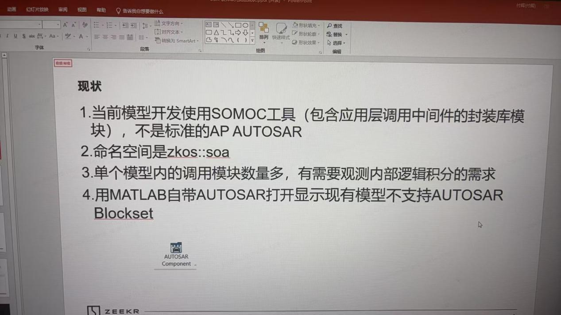

**SOMOC Tool Generated Code Format：**

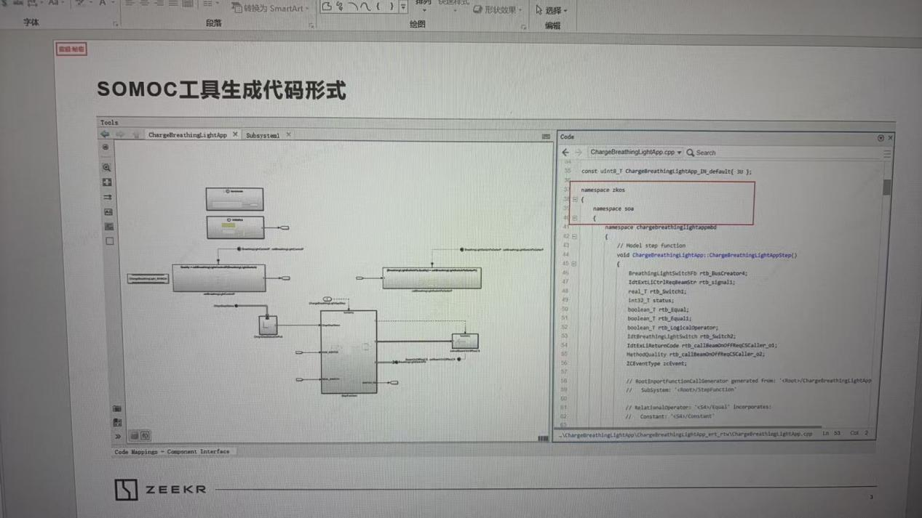

**Model Interface Types**

1. The interface used is Bus Element In/Out

Code generation configuration: ert.tlc

1. The interface used is Function Element, Function Element Call

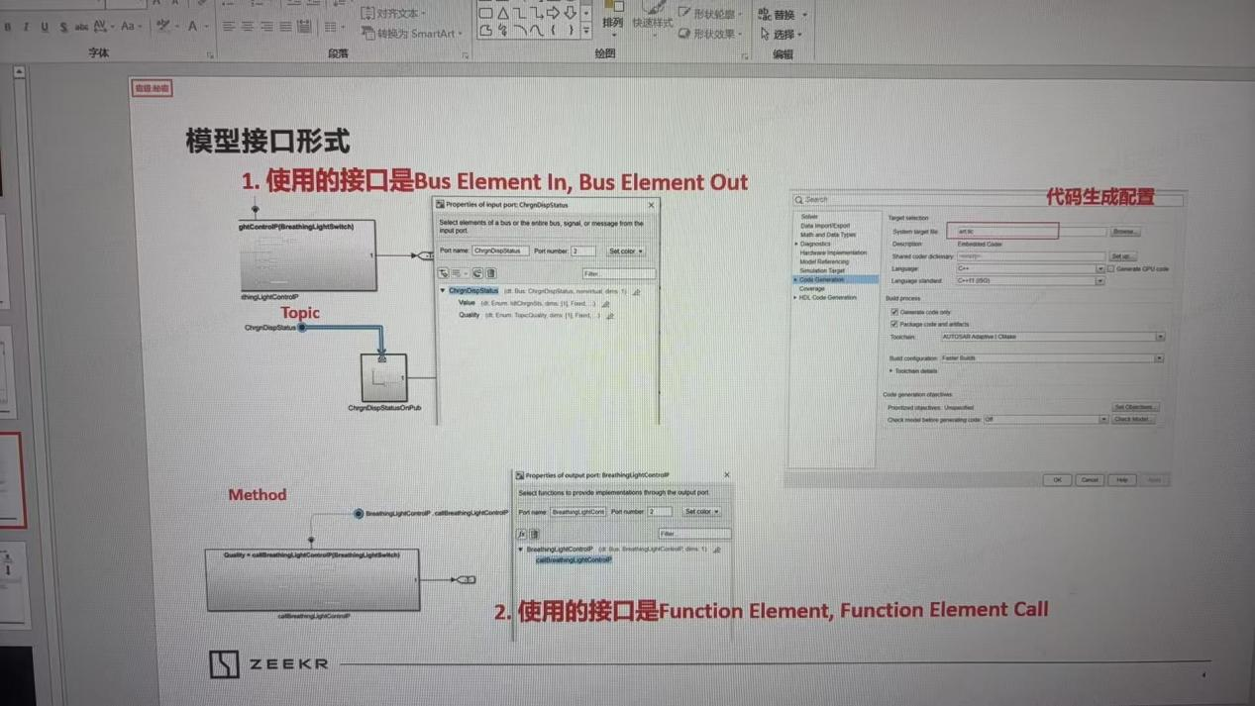

After configuring AP AUTOSAR, the generated code reports an error: The existing model does not support AUTOSAR Blockset：

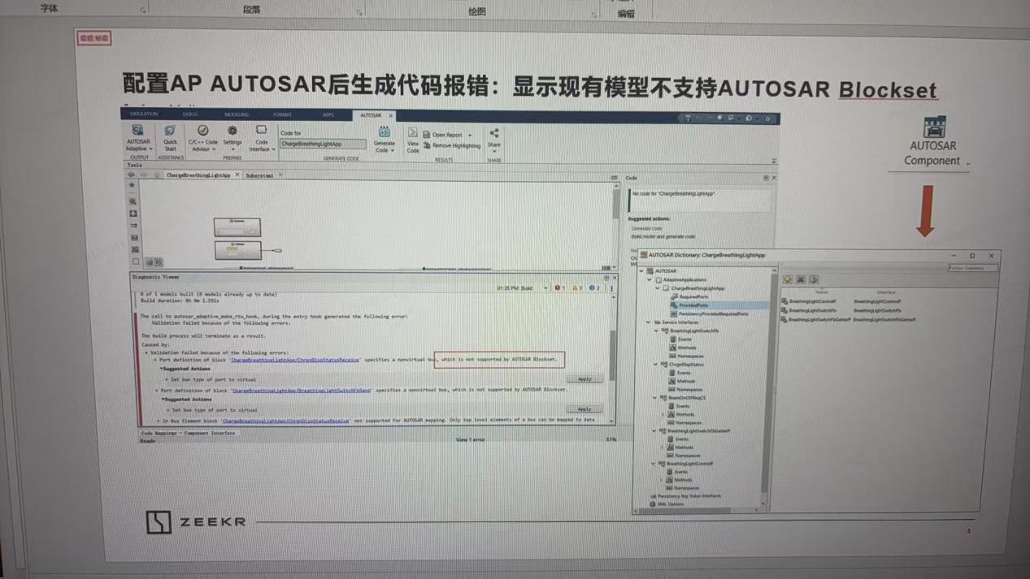

**Required Objectives:**

1. Provide modification methods to ensure the model runs properly and supports dynamic testing.

2. Provide corresponding unit testing tools and methods.